Ms. Selby’s Classroom Management Plan
- Procedures for Students
  - Work Requirements
    - Students will complete their work in an individual or group basis as assigned. Students will follow instructions and work diligently. Students will maintain the noise level explained at the beginning of instruction. Prior to turning in work students will mark their names and class number with a highlighter to help ensure all assignments are turned in with a name.
  - Absenteeism
    - Students are responsible for getting work from the Absent Work Bin. They will find the divider labeled the day they miss. Work will be clipped together. Students will make up absent work in designated class times and study hall time if possible. All absent work will be due by the designated campus guideline regarding absences.
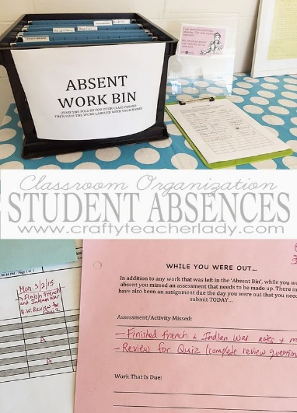

  - Walking into Class
    - Students will hang up backpacks on hangers in the hall. Teacher will greet each student as they enter the class. Students will turn in their homework folders in the Homework Bin. Students will go to the lunch board and choose lunch. Students will then be seated and read the morning message on the smart board and immediately begin the day of the week work from their morning stretch worksheet.
  - Notes from Home
    - Notes from home will be turned in with the homework folder to the teacher as students are greeted coming in to the classroom.
  - Classroom Tardiness
    - Students will come in quietly and sign the tardy clipboard on the announcements board. They will put homework folder in the attached bin so not to interrupt class instruction.
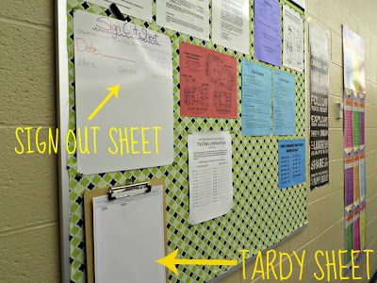

- Procedures of the Classroom
  - Beginning of Class
    - After announcements, students will finish their morning stretch work. Students will show the teacher that they have completed their morning work by reading quietly. When all students have completed their stretch, regular instruction will begin.
  - All Transitions
    - Teacher will use timer and warnings of time left to prepare students for transition. When it is time for students to put things away to prepare for next instruction, the teacher will use a timer to signal students to clean up or put away. Teacher will then count backwards from 5 after giving instruction of where students should be to ensure smooth transitions within the room or to and from different rooms.
  - Getting Student’s Attention
    - Teacher will say “Class, Class” students will respond with “Yes, Yes”. Students will be prepared to hear further instruction.
  - Classroom Jobs
    - Classroom jobs include line leader, caboose, lights, and passing out papers. Jobs will be posted by the classroom door and students will know their job because their name clip will be attached to the job. Students will perform the job for the week. Names will be drawn by the teacher at the end of the day Friday or first thing Monday to make sure new assignments are always given.
  - Student Location
    - When given permission to go to different locations, students will move their number magnet on the board by the announcements board to the location they are going. Upon returning to the classroom, students will put their number magnet back to the in-class spot.
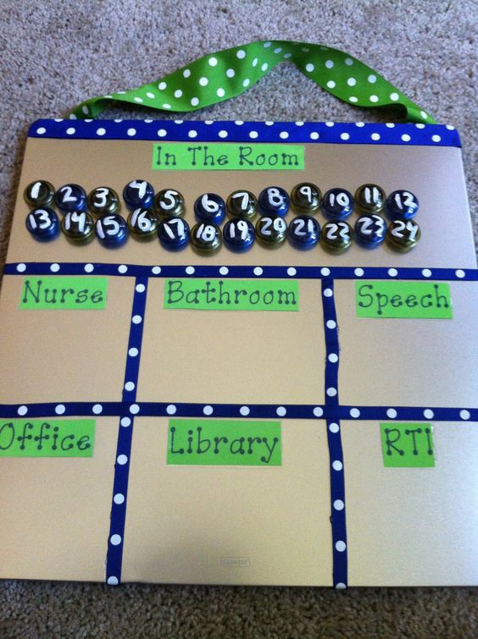

  - Non-Verbal Signals
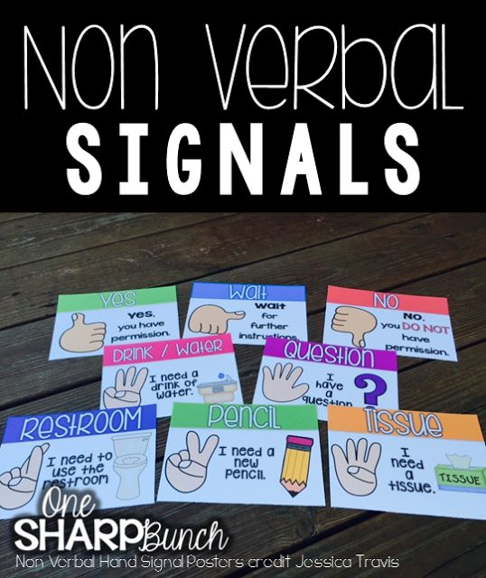
    - If students have a need during class, they will use a nonverbal signal and wait for the teacher’s nonverbal signal response. If the student needs a new pencil, they will raise their hands and hold up two fingers. If students need a drink of water, they will raise their hangs and hold up three fingers. If they need a tissue, they will raise their hands and hold up four fingers. For questions, they will raise their hands and hold up five fingers. If the students need to go to the restroom, they will raise their hand and make the letter R in sign language. The teacher will respond with a thumbs up for yes, a thumbs down for no, or a thumbs sideways for wait. The nonverbal signals will be posted next to the classroom norms as a reminder for students.

- Procedures for Instruction
  - Collaborative Group Work
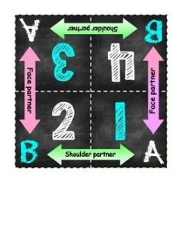
    - Kagan group work chart will be attached to tables of four. The chart numbers students, helps them recognize shoulder and face partners, and also uses letters to work with diagonal partners. Group work and who students will work with will be assigned by the teacher.
  - Cultivating Social Skills
    - Students will work in groups or pairs for most class activities and lessons. Students will also have time for centers to encourage use of social skills. Students will use the golden rule and treat others the way they would want to be treated. Students will be graded on participation. Student behavior will be measured by the color system as well as through their behavior bank register. Students will debit for not following procedures and will credit for being helpful, going above and beyond and turning in classwork.
  - What to Do When Done with Work
    - When finished with work students may watch soothing videos on computers, draw, work in centers on a quiet level, or read their AR books.
  - Class Discussions
    - Class discussions will be held in both an in class and online format. Students are to be courteous and respectful in their own input and in responding to other students. If discussions are in class and an open discussion, students will take turns speaking. When working in groups or pairs, students will use inside level one voices so that everyone can hear their partner or group at a controlled noise level.
  - Taking a Test
    - Students will clear their desks and will take a privacy folder from the shelf. Students will keep their eyes on their own papers and follow any individual testing procedures if necessary.

- Procedures for Teacher
  - New Student Orientation
    - Teacher will introduce the new student to the way the class is run and make the new student feel welcome while keeping the class on task with minimal interruption. The student will be introduced to the class and students will be trained in being welcoming to the student. New student will be given copies of important documents from the new student binder and will be assigned a new student buddy to help show them around the class as well as the school. Teacher will assign new class numbers if needed and ensure the new student checklist is completed.

  - Parent Volunteers
    - Teacher will ask parents at open house if anyone is willing to volunteer as room mom or dads. This team will be responsible for helping plan for class parties and volunteering when possible. Parents can email times they would like to volunteer or teacher will email requesting special help with tasks to prepare for lessons. Teacher will keep on hand items for volunteers to help with such as copying or cutting and pasting items, among other tasks. Teacher will coordinate communication between main room mom/dad and other parents.
  - Technology in the classroom
    - Prior to online use in the class, parents will sign a student waiver giving students permission and if students can use email, blogs, internet browsing, or shared documents. Students will sign and follow the online safety pledge presented in the first weeks of class and kept as a reference. The teacher will monitor technology use. Students will be debited for improper technology use.
  - Home and School Connection
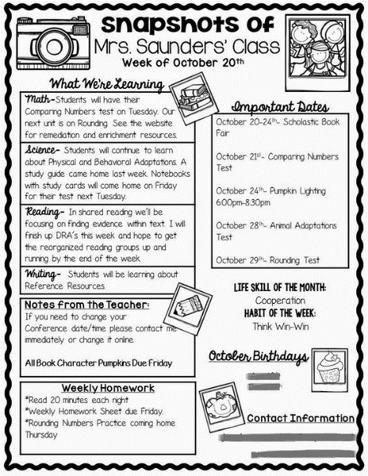
    - Teacher will create a class website and give access to parents. Weekly newsletters with important news, announcements, and upcoming dates will be emailed to parents. Parents will also have the option of leaving a voicemail for the teacher if they would prefer communicating by phone.

  - Student Feedback
    - Students will have several ways of communicating with the teacher including in person when appropriate time, nonverbal communication, email, or leaving a question/statement in the comment box.

  - Substitute Teacher Handbook
    - Teacher will create a substitute teacher handbook that will always be placed on the desk at the end of each day in case the teacher has an unexpected absence. Handbook will include a thank you note for their help, a copy of classroom procedures, student roster, logins or important phone numbers, a summary introducing him/her to the class or classes, copies of the lesson plans with copies of handouts, and a substitute feedback survey to let teacher know how the class did in her absence.
